**SPARQL queries**

**Part 1 : Write SPARQL queries to response to the following:**

1. **List the instances of the class Actor**

SELECT DISTINCT ?prenom ?nom WHERE{?Actor this:isActorOf ?Movie.

?Actor this:fistname ?prenom.

?Actor this:lastname ?nom. }

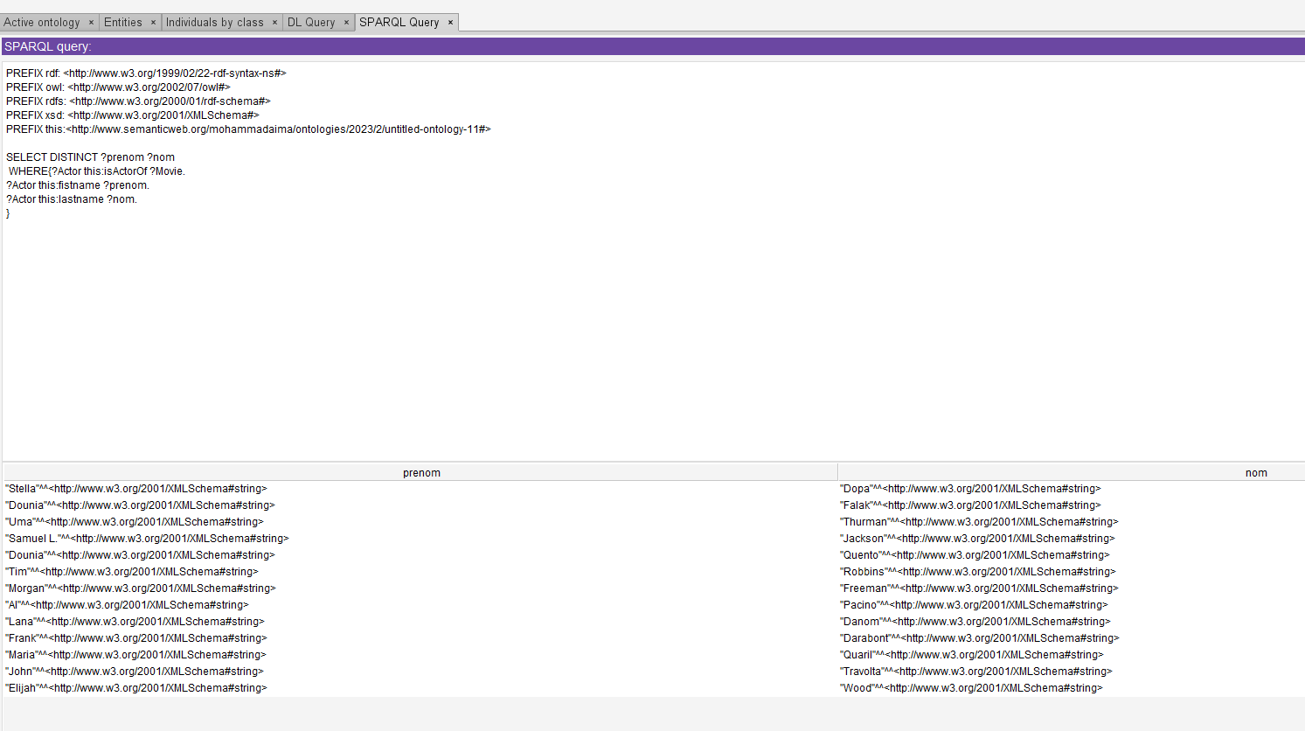

1. **List the name of all Thriller movies. For each one, display its director.**

SELECT DISTINCT ?Thriller_movie ?director

WHERE{

?Thriller_movie rdf:type this:thriller.

?director this:isDirectorOf ?Thriller_movie.

}

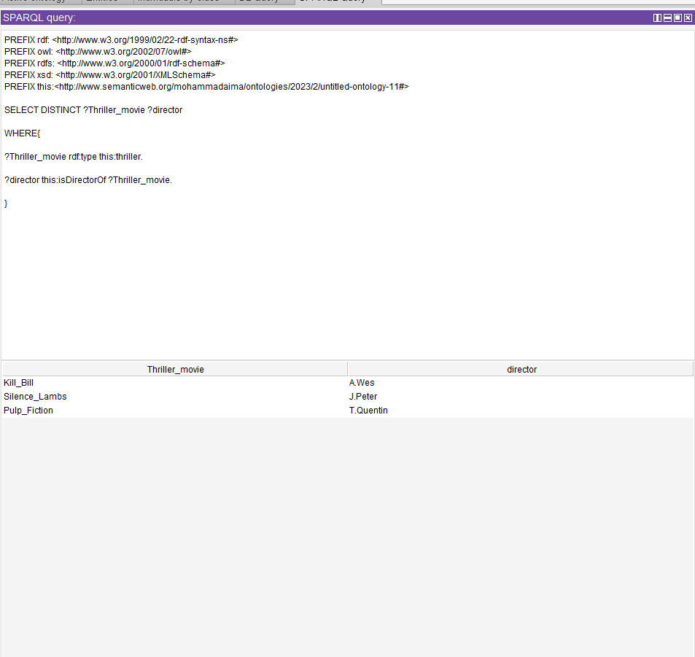

1. **List the name of all Crime Thriller movies.**

SELECT DISTINCT ?Thriller_Crime_movie

WHERE{

?Thriller_Crime_movie rdf:type this:thriller.

?Thriller_Crime_movie rdf:type this:crime. }

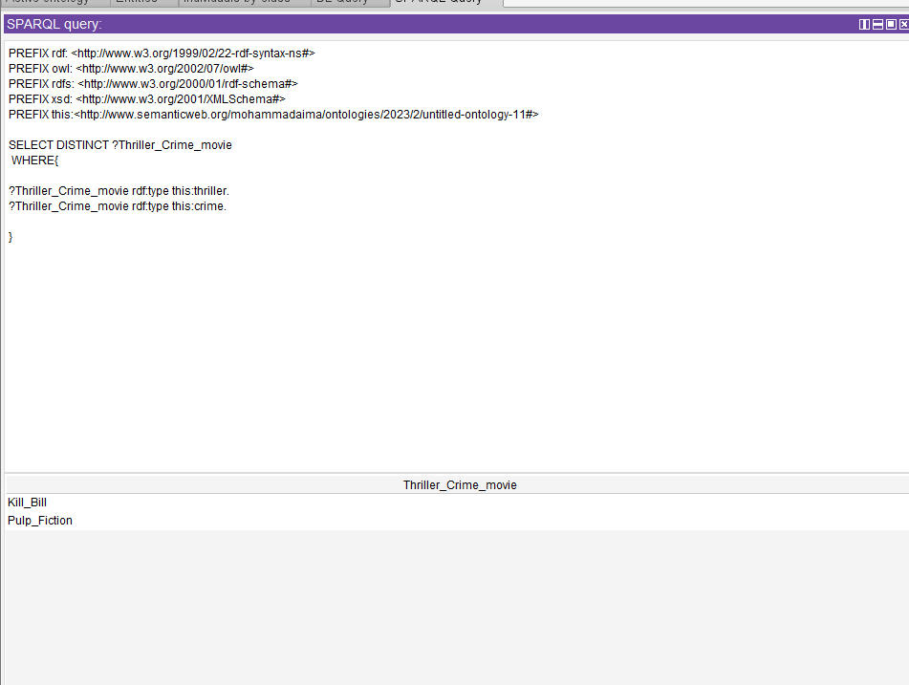

1. **List the name of Actors older than 51 years.**

SELECT DISTINCT ?prenom ?nom ?age

WHERE{

?Actor this:isActorOf ?Movie.

?Actor this:age ?age.

?Actor this:fistname ?prenom.

?Actor this:lastname ?nom.

FILTER(?age>"51"^^xsd:positiveInteger).

}

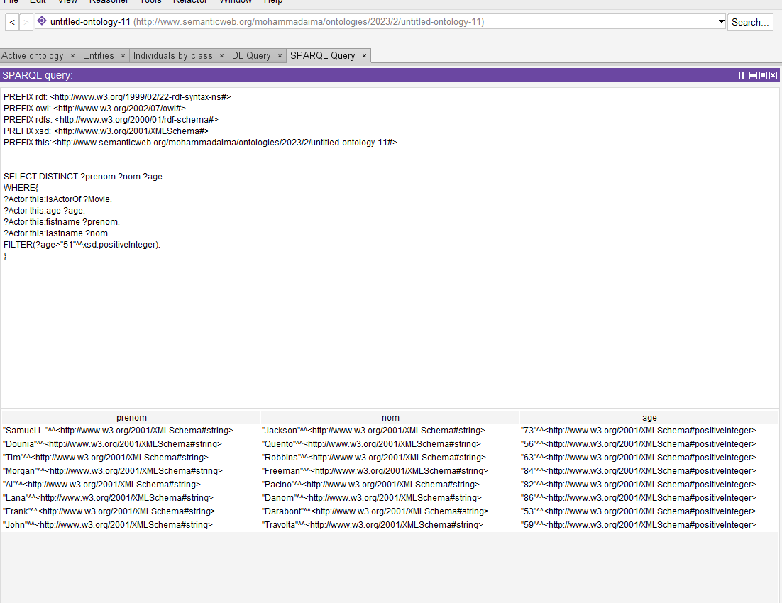

1. **List of movies that are played in theater for a specific day and where and until when**

SELECT ?movie ?date_fin ?cinema WHERE

{

?movie rdf:type this:movies.

?movie this:hasSchedule ?x.

?x this:end_released_date ?date_fin.

?x this:released_date ?d.

FILTER((?d<"1998-02-09T10:30:13"^^xsd:dateTime)&&(?date_fin>"1998-02-09T10:30:13"^^xsd:dateTime)).

?cinema this:isSchedule ?x.

}

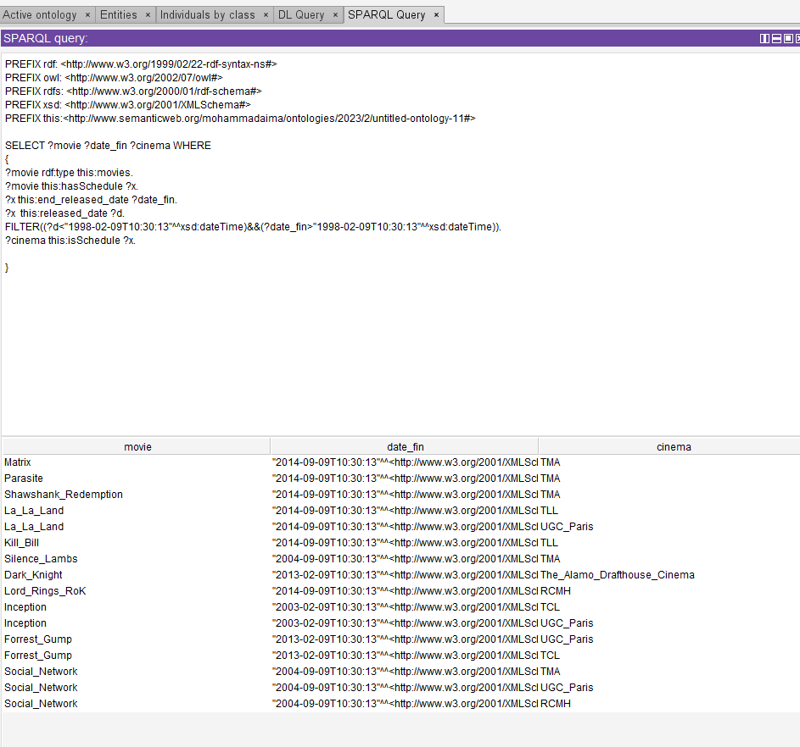

**Part 2 : Propose 5 SPARQL queries:**

1. **A query that contains at least 2 Optional Graph Patterns**

The OPTIONAL is used to specify optional graphs in a SPARQL query. This means that the graph is optional, i.e. it may or may not be present for the query results. Here we select all movies and in the first option the directors are displayed and in the second option the duration of the films that are less than 140 minutes is displayed.

SELECT DISTINCT ?Movie ?director ?duration WHERE{

?Movie rdf:type this:movies.

?Movie this:duration ?duration.

OPTIONAL{ ?director this:isDirectorOf ?Movie.}

OPTIONAL{ ?Movie this:duration ?duration.

FILTER (?duration < "140"^^xsd:positiveInteger)}

}

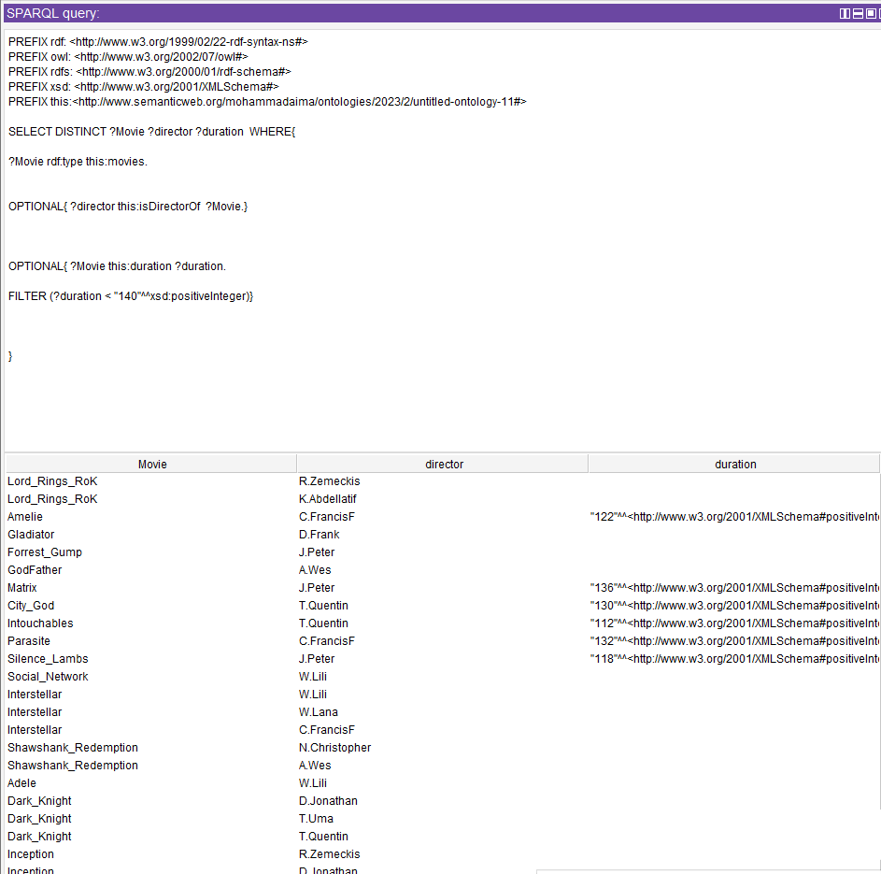

1. **A query that contains at least 2 alternatives and conjunctions**

A search query that uses logical operators to refine the search results. Here we use "UNION" and "AND. We select actors by two age ranges: actors whose age is between 18 and 20 or actors whose age is between 40 and 55.

SELECT ?nom ?prenom ?age

WHERE{

{?Actor this:isActorOf ?Movie.

?Actor this:age ?age.

FILTER (?age>="18"^^xsd:positiveInteger && ?age<="20"^^xsd:positiveInteger)}

UNION

{?Actor this:age ?age.

FILTER (?age>="40"^^xsd:positiveInteger && ?age<="55"^^xsd:positiveInteger)}

?Actor this:fistname ?prenom.

?Actor this:lastname ?nom.}

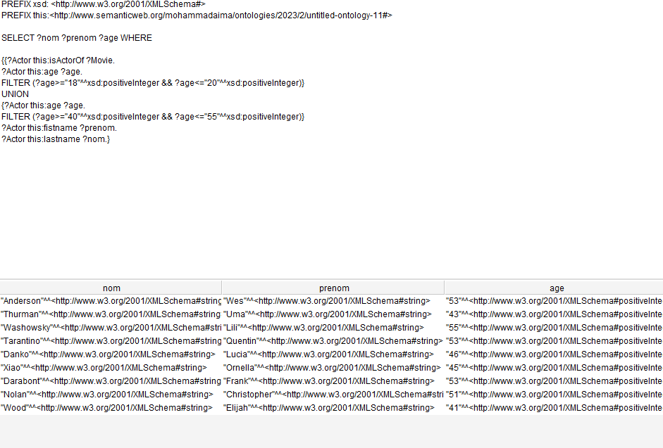

1. **A query that contains a CONSTRUCT query form**

A query that contains a CONSTRUCT query form is a SPARQL query used to construct a new RDF data graph from an existing data graph. Here we create a new graph with as triplet the title of the movie, the director of the movie and the duration of the movie.

CONSTRUCT {

?movie this:title ?title.

?movie this:director ?director.

?movie this:duration ?duration.}

WHERE

{?movie rdf:type this:movies.

?movie this:title ?title.

?director this:isDirectorOf ?movie.

?movie this:duration ?duration.}

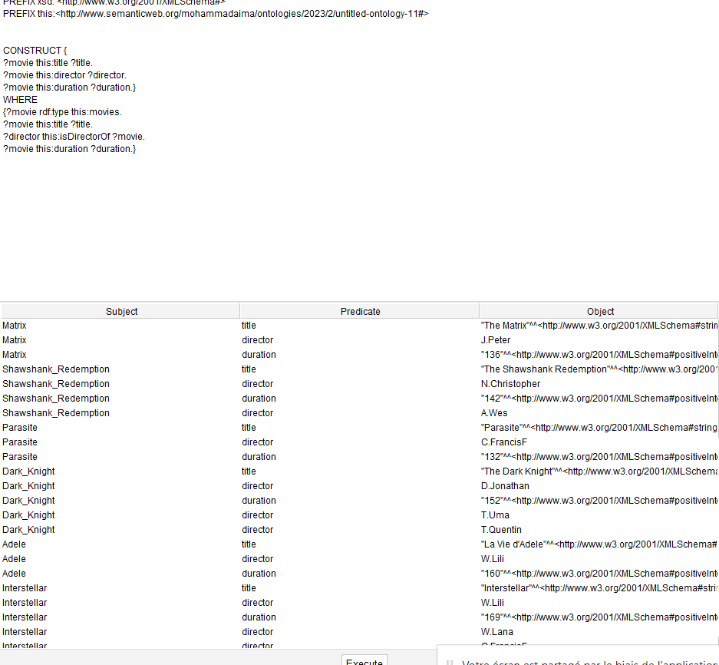

1. **A query that contains an ASK query form**

A query that contains a form of ASK query is a SPARQL query used to ask a question about an RDF data graph. The ASK query returns a boolean result. Here we want to know if Morgan Freeman is an actor in our database.

ASK WHERE{

?Actor this:isActorOf ?Movie.

?Actor this:fistname "Morgan"^^xsd:string.

?Actor this:lastname "Freeman"^^xsd:string.

}

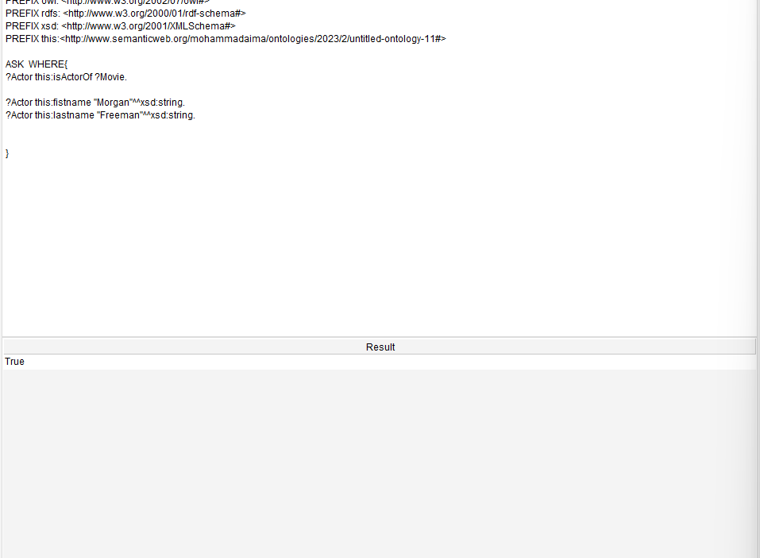

1. **A query that contains a DESCRIBE query form**

A query that contains a DESCRIBE query form is a SPARQL query used to return a description of a specified RDF resource. Here we describe the genre subclass: comedy.

DESCRIBE ?movie_comedy

WHERE {

?movie_comedy rdf:type this:comedy.

}

